**DAILY ONLINE ACTIVITIES SUMMARY**

|  |  |  |  |  |  |  |  |  |
| --- | --- | --- | --- | --- | --- | --- | --- | --- |
| **Date:** | 13/06/2020 | | | | | **Name:** | CHANDANA S | |
| **Sem & Sec** | 4th SEM ‘A’ SEC | | | | | **USN:** | 4AL18CS016 | |
| **Online Test Summary** | | | | | | | | |
| **Subject** | | Data Communication(18CS46) | | | | | | |
| **Max. Marks** | | 30 | | **Score** | | | 29 | |
| **Certification Course Summary** | | | | | | | | |
| **Course** | Microsoft Azure Essentials | | | | | | | |
| **Certificate Provider** | | | Great Learning | | **Duration** | | | 3 Hours |
| **Coding Challenges** | | | | | | | | |
| **Problem Statement:**1. Write a C Program to calculate Electricity Bill.  2.Write a java program to find the first non repeated character of a given String. | | | | | | | | |
| **Status:** Completed | | | | | | | | |
| **Uploaded the report in GitHub** | | | | | YES | | | |
| **If yes Repository name** | | | | | https://github.com/chandushivalingareddy/lockdown-coding | | | |
| **Uploaded the report in slack** | | | | | YES | | | |

**Online Test Details:**

The online test was from module 1 and 2 which was about the Introduction to Data Communication, Networks models, Introduction to Physical Layer-1, Digital Transmission, Physical Layer-2. There were 30 questions and the duration was 30 minutes. The questions were optimal and were easy. The score that I got in the test is 29/30.

**Snapshot:**

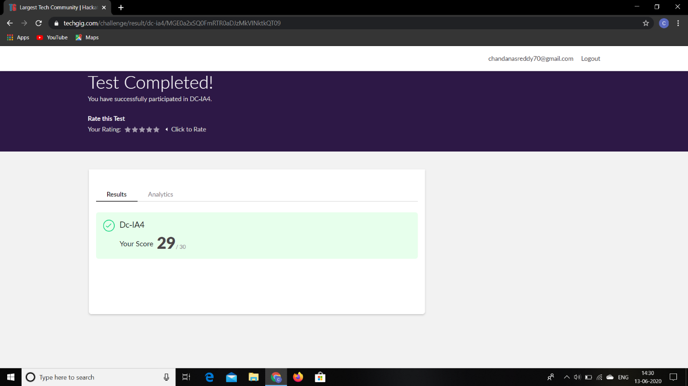

**Certification Course Details:**

**Name of the course**: Microsoft Azure Essentials

**Certificate Provider**: Great Learning

Today I went through the six modules of the course that explained about Storage Compute and Networking.

**Snapshot:**

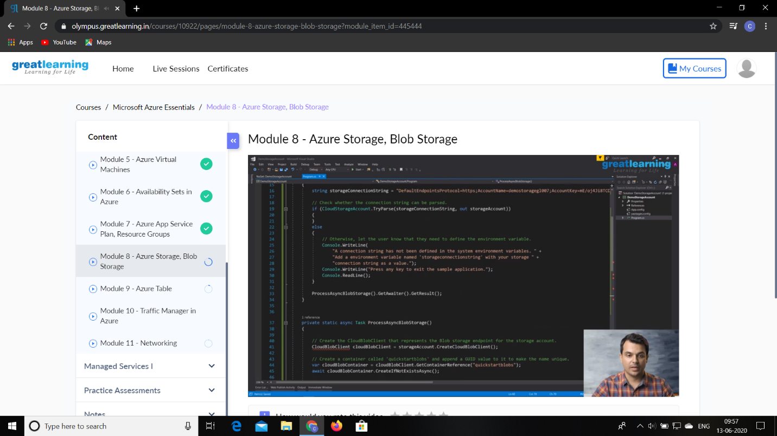

**Online Coding Details:**

Problem 1: (using C language) To calculate Electricity Bill.

**Snapshot:**

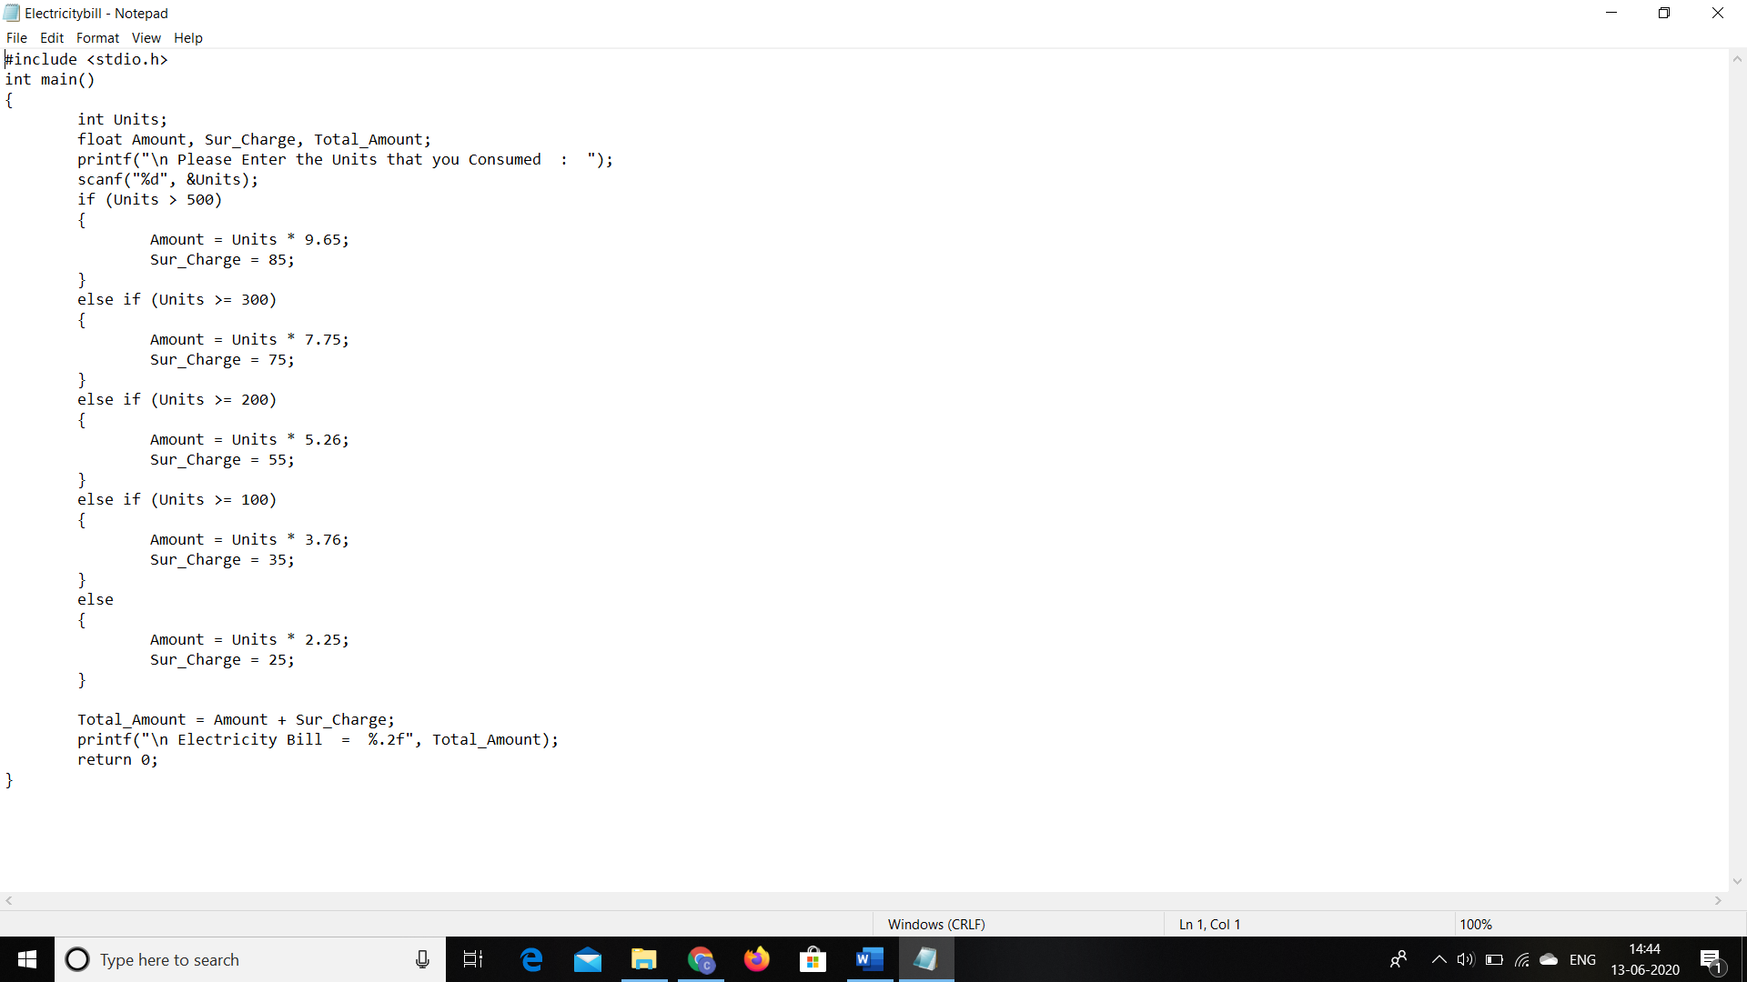

Problem 2:(using java language) to find the first non repeated character of a given String.

**Snapshot:**

